

**Dhaka University of Engineering & Technology, Gazipur**

Department of Computer Science and Engineering

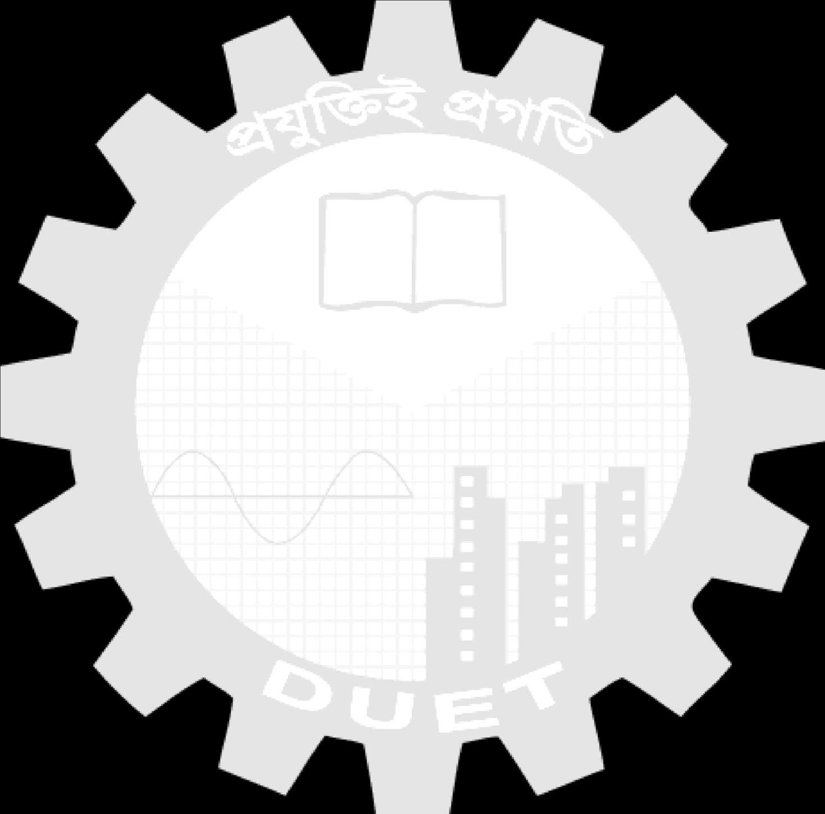

Course Code: CSE 2110

Course Title: Advance programming sessional

**Project Proposal**

1. BOTOCHAT
2. COACHING MANAGEMENT SYSTEM

|  |  |  |  |
| --- | --- | --- | --- |
|  |  |  |  |

COACHING MANAGEMENT SYSTEM

**Submitted To**

**Dr. Umme Fawzia Rahim**

Lecturer

Department of CSE

DUET, Gazipur

**Md. Rajibul Islam**

Lecturer

Department of CSE

DUET, Gazipur

|  |  |  |  |
| --- | --- | --- | --- |
| Date of Submission : 31/ 07 / 23 |  |  |  |



**Submitted By**

Name: Md. Abdul Owadud islam Raton

Golam Mostafa Rabby

Student ID: 214033, 214036

Year/Semester: 2ndYear/ 1st Semester Section: A

Signature of Teacher